  IMTMA – ACE MICROMATIC  Productivity Championship Awards - 2025 |  |  |  | ENTRY FORM
 |  |  |  | Organization : |  |  | Tata Electronics
 |  |  |  | Principal author: |  |  | Mr. Karthik Siddhan
 |  |  |  | Designation: |  |  | Sr. Manager
 |  |  |  | Phone/ Mobile : |  |  | +91 9900726865
 |  |  |  | Email *: |  |  | karthik.siddhan@tataelectronics.co.in
ABSTRACT OF CASE STUDY
(Before filling the form please read the guidelines and rules)
1. | Industry Sector:  (Choose from the dropdown) | Choose an item.
 |  | Others(Specify) : | EMS industry
2. | Size of the industry | MICRO & SMALL ENTERPRISE  (Unit level turnover <100 Crores.  Excludes SBUs of large corporates) |  |  | LARGE AND MEDIUM COMPANIES  (Unit level / SBU level turnover > Rs.100 Crores) |  |  | Turnover  (in Rs. Cr)  5563
3. | Title : Revolutionizing CNC Automation without Robots
4 | Is the Project under continuous operation YES NO ☐
5.
  Scope of the Project: | Localized Point Improvement |  | Line Improvement |  | Companywide Improvement
5. | Date:(must be implemented after January 2021) | Start Date : 20-June-2024 |  |  |  | Completion Date : 12-Dec-2024
6
  Team Composition / Structure | Department resources |  | CFT – Cross Functional Team (Company resources)
7. | Streams
7.
  Manufacturing System Redesign |  | Optimizing Metal Working Process |  | Better  Asset Utilization |  | Productivity Through Quality Improvement |  | Productivity Improvements in Small & Medium Enterprises (SME) |  | Others if any  (Specify)
  Cellular manufacturing, | ☐ | Metal removal process |  | Maximize overall equipment efficiency |  | Quality cost |  | To recognize SMEs which have taken up productivity improvement projects | ☐
  Factory within factory | ☐ | Metal forming process | ☐ | Space optimization | ☐ | Appraisal | ☐ | and to join the productivity movement, an exclusive stream has been slotted.
  Reducing throughput time |  | Forging | ☐ | Inventory management | ☐ | Internal  failure | ☐
  Minimize setup/load/unload times |  | Die casting | ☐ | Smart application of CAD / CAM / Software tools | ☐ | External  failure | ☐ | SMEs can compete under SME stream or any of the other streams | ☐
  Tool management | ☐ | Heat treatment | ☐ | Leveraging IT | ☐ | Real time/in-process metrology | ☐
  Work holding | ☐ | Plating | ☐ | Product Redesign | ☐ | POKA- YOKE
   |  | Painting | ☐ | Process redesign |  | Zero defect
   |  | Surface coating | ☐
   |  | Assembly | ☐
   |  | Finishing operations | ☐

8. | Reason for problem selection? |  |  | Responsive |  |  |  |  |  |  |  | Proactive ☐
8. | Brief description:  - High Defect Rate: Dent and damage defect rate (FR) is around 10% to 12%, leading to quality issues.  - Skilled Operator Dependency: Requires a highly skilled operator to load and unload parts accurately, limiting workforce flexibility.  - Manual Handling Risks: Inconsistent human handling increases the chance of misalignment, scratches, and deformations.  - Productivity Constraints: Operators require breaks and shift changes, reducing CNC machine uptime.  - Ergonomic Concerns: Continuous manual loading can lead to operator fatigue and inefficiency, impacting overall productivity.  - Operational Cost Impact: Higher dependency on skilled labour increases manpower costs and reduces profit margin.
9. | Uniqueness of the project if any? | Approach | New concept |  |  |  |  | ☐ | Breakthroughs |  |  |  |  |  |  |  |  | Patents
9. | Uniqueness of the project if any? | Results | Improvement % to base line
9. | Uniqueness of the project if any? | Results | 20 – 30% |  |  | ☐ | 30-40% |  |  |  | ☐ |  | 40-50% |  |  |  | ☐ |  | >50%
9. | Uniqueness of the project if any? | Results | Status
9. | Uniqueness of the project if any? | Results | First time in the company |  |  |  |  |  | First time in industry |  |  |  |  |  |  |  |  | Trend setter
10. | Tools used, (7 QC Tools , New 7 QC Tools, 6 Sigma , DOE , Theory of Constraints, Shainin Techniques, Project Management tools, Lean approach, Manufacturing system redesign, Digital manufacturing, TQM approach, TRIZ)  (Based on the tools used in the project, multiple options can be selected from the given dropdowns) |  |  |  | Manufacturing system redesign  TRIZ  Choose an item.  Choose an item.  Others(Specify): |  |  |  |  |  |  |  |  | Choose an item.  Choose an item.  Choose an item.  Choose an item.

11. | A brief insight into the Project (Not exceeding 500 words)  - Our innovation in CNC automation redefines traditional manufacturing workflows by eliminating the dependency on robotic systems for part loading and unloading. At the heart of this solution is an advanced integration of smart material handling and precision fixturing. Unlike conventional approaches that rely heavily on robots—often associated with high capital costs and complex integration—our system uses adaptive fixturing and sensor-based positioning to securely and accurately manage parts throughout the CNC process. This breakthrough allows manufacturers to automate material transfer without altering or upgrading existing CNC machines, offering a scalable, cost-efficient path to smarter production.  - One of the most compelling advantages of our system is its ability to significantly reduce human error, a common source of production defects and operational delays. Manual handling frequently results in surface damage such as dents, scratches, or misalignment, all of which compromise product quality and increase rework. Our specialized fixturing solutions ensure each part is precisely aligned and securely held during movement, regardless of material softness or shape complexity. By protecting parts from damage and minimizing manual intervention, the system not only maintains high quality standards but also reduces waste and rework costs, contributing to more sustainable and efficient manufacturing practices.  Moreover, the automation of loading and unloading boosts overall production speed and throughput. The intelligent system dramatically reduces cycle times, streamlines workflows, and enables faster turnarounds—critical factors for meeting tight delivery schedules. Importantly, this increase in efficiency is achieved without requiring extensive operator retraining or expensive new machinery. Our solution seamlessly integrates into existing CNC setups, making it an accessible innovation for manufacturers of all sizes. By combining advanced fixturing with smart handling in a non-robotic framework, we provide a transformative approach to CNC automation—one that enhances productivity, ensures product quality, and delivers long-term cost savings.
 | 11.1 | Reason for choosing the project:  TEPL operates an impressive fleet of over 4,000 CNC machines, enabling the production of more than 50000 smartphone enclosures each day. This remarkable capacity positions TEPL as a leader in the Indian manufacturing sector, particularly in the realm of precision engineering. The operation of these CNC machines is predominantly managed by skilled women, with each operator responsible for overseeing ten machines simultaneously on the production line. The process involves manually loading each component into the CNC machines for machining, which introduces a unique set of challenges, particularly given the rapid cycle times of less than 180 seconds.  Due to the sensitive nature of the parts being produced, which are crafted from a specialized aluminium alloy, the loading and unloading processes are critical. These components are highly susceptible to dents and damage during handling, necessitating a meticulous approach to ensure their integrity. The deformation of these parts can significantly impact their ability to meet stringent dimensional specifications, making it essential to maintain a consistent and careful load and unload procedure within the CNC machining fixtures.  To uphold the quality standards required in this manufacturing environment, operators must adhere strictly to cleaning protocols for both fixtures and parts. Any deviation from these cleaning procedures can trigger machine alarms related to part seat checks, resulting in costly downtime. Therefore, the emphasis on a disciplined and systematic approach to both the loading process and the maintenance of equipment cleanliness is vital for sustaining operational efficiency and product quality in TEPL's manufacturing operations
 | 11.2 | Objectives/ Target set for the project: (Outcome to be quantified)  - Reduced Dent and Damage Failure Rate from 10% to 0.5%  - Head Count saving per line: 120  - Machine uptime increased by 7% (21.75 Hrs. to 23.25 Hrs.)  - Dimensional yield increased from 88% to 99.5%  - Safety enhancement from 80% to 100%  Localization increased from 20% to 100%
 | 11.3 | Implementation details in brief (Not exceeding 200 words)  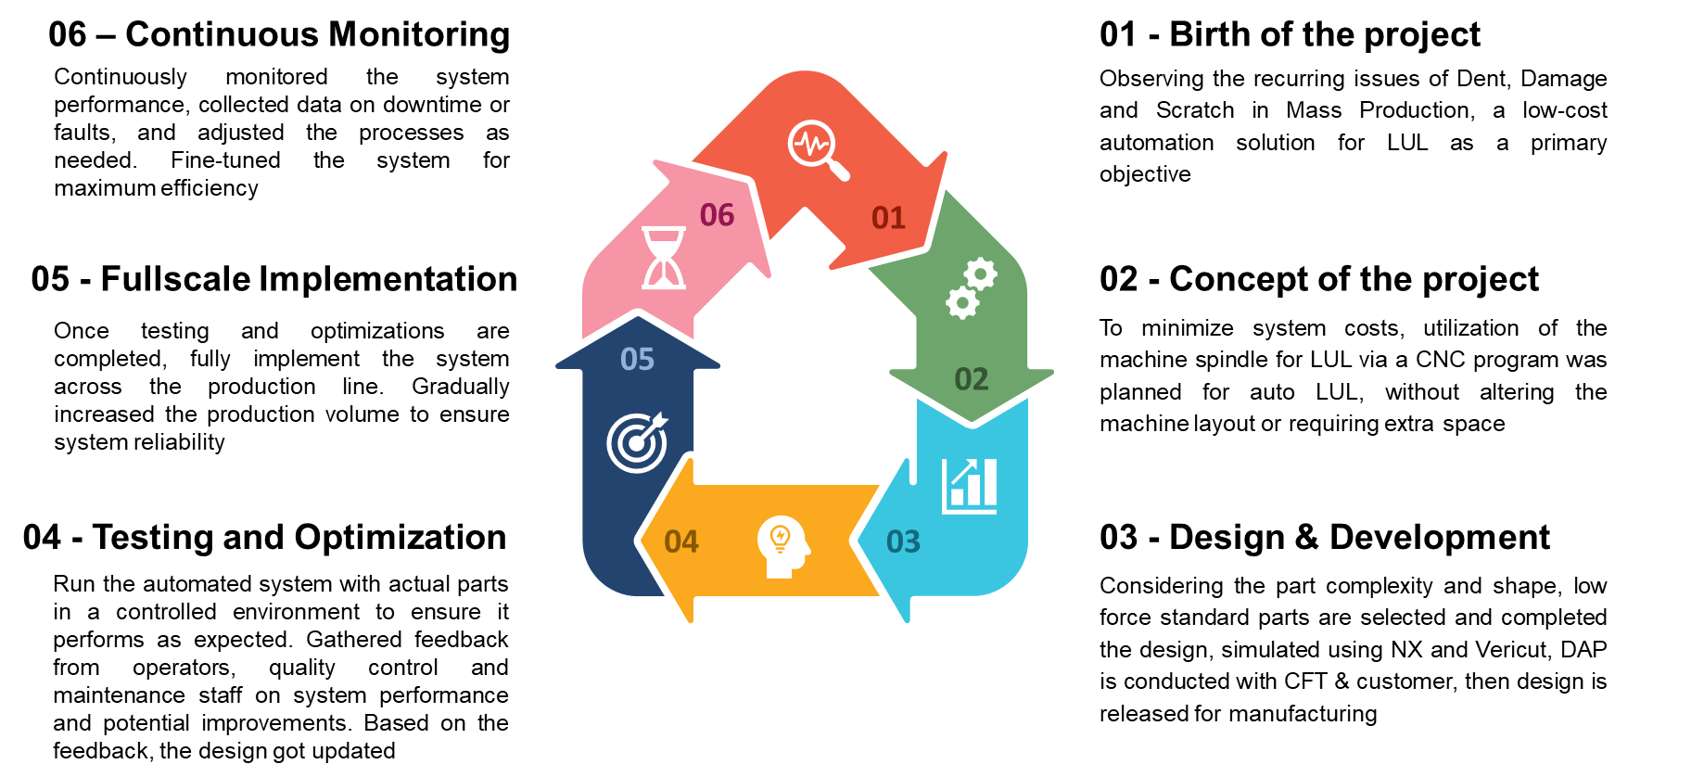  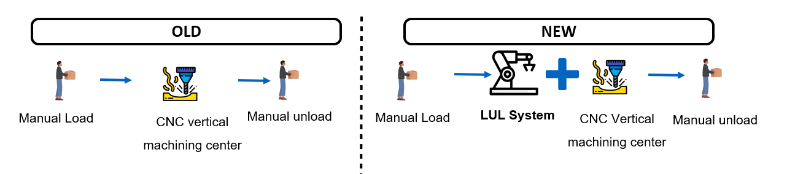
 | 11.4 | Overall schematic flow diagram for the project from start to completion:  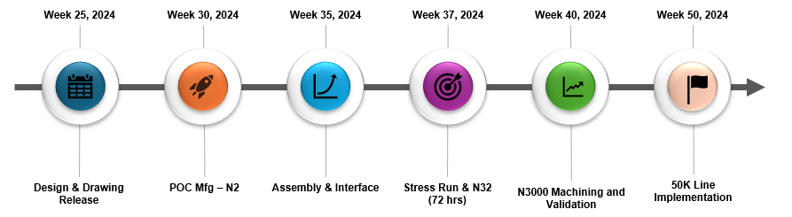
 | 11.5 | Operational Benefits – Covering Productivity, Quality, Cost, Delivery, EHS (To be quantified)  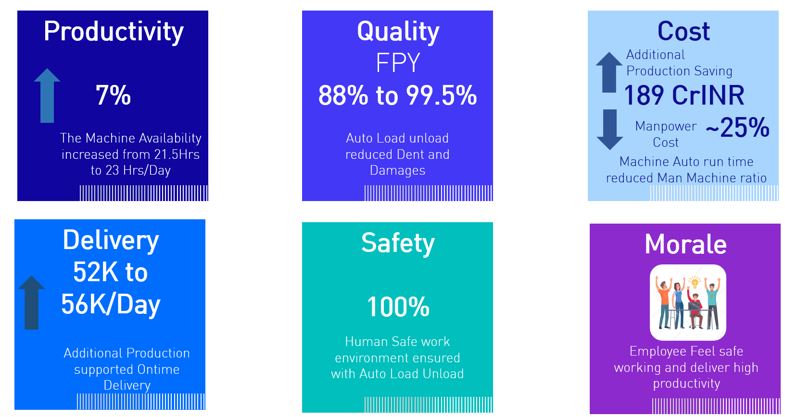
 | 11.6 | Business Benefits: Cost benefit ratios, Savings one time & recurring, Investment vs Return, Market share  The direct savings of INR 189 Crore are attributed to a 7% increase in machine availability, which has led to enhanced production efficiency and a reduction of 120 headcount for a daily output of 52,000 units. This improvement underscores the financial benefits of optimizing operational capabilities.  As TEPL embarks on the construction of additional capacity plants, the anticipated daily production volume is projected to reach 100,000 units by June 2026. The recurring nature of the INR 189 Crore savings will significantly contribute to the company's long-term financial health and operational sustainability.  The return on investment (ROI) analysis reveals that the CNC Auto LUL costs will achieve breakeven within just seven months following implementation. This swift recovery period highlights the effectiveness of the investment in enhancing production processes and overall profitability.
12. | ** We Certify that we are classified as a Micro / Small with the Udyam Registration Certificate number: __________with the Major Activity as___________ [Please ignore if it is not applicable to your company]
Company Authorization
We certify that the project described here is factually correct and is in continuous operation. We confirm that we have read the rules and guidelines governing this competition and agree to abide by the same.
Name : Palanivel. Designation : DGM Signature :

Date :

*All future communication will be the principal author/project leader through email at this email ID
**If you are competing under SME stream, please certify your status as an SME, else you may leave it blank

