  IMTMA – ACE MICROMATIC  Productivity Championship Awards - 2025 |  |  |  | ENTRY FORM
 |  |  |  | Organization : |  |  | Lucas TVS Ltd., Padi
 |  |  |  | Principal author: |  |  | Mr. Ramasami M
 |  |  |  | Designation: |  |  | Sr. Manager
 |  |  |  | Phone/ Mobile : |  |  | +91 91500 94720
 |  |  |  | Email *: |  |  | ramasami.m@lucastvs.co.in
ABSTRACT OF CASE STUDY
(Before filling the form please read the guidelines and rules)
1. | Industry Sector:  (Choose from the dropdown) | Automotive and Auto Components
 |  | Others(Specify) :
2. | Size of the industry | MICRO & SMALL ENTERPRISE  (Unit level turnover <100 Crores.  Excludes SBUs of large corporates) |  |  | LARGE AND MEDIUM COMPANIES  (Unit level / SBU level turnover > Rs.100 Crores) |  |  | Turnover  (in Rs. Cr)  ______________
3. | Title : Zinc plating plant enhancements: Capacity, Quality & sustainability.
4 | Is the Project under continuous operation YES ☐ NO ☐
5.
  Scope of the Project: | Localized Point Improvement | ☐ | Line Improvement | ☐ | Companywide Improvement | ☐
5. | Date:(must be implemented after January 2021) | Start Date : 01.02.2024 |  |  |  | Completion Date : 31.08.2024
6
  Team Composition / Structure | Department resources | ☐ | CFT – Cross Functional Team (Company resources) | ☐
7. | Streams
7.
  Manufacturing System Redesign |  | Optimizing Metal Working Process |  | Better  Asset Utilization |  | Productivity Through Quality Improvement |  | Productivity Improvements in Small & Medium Enterprises (SME) |  | Others if any  (Specify)
  Cellular manufacturing, | ☐ | Metal removal process | ☐ | Maximize overall equipment efficiency | ☐ | Quality cost |  | To recognize SMEs which have taken up productivity improvement projects | ☐
  Factory within factory | ☐ | Metal forming process | ☐ | Space optimization | ☐ | Appraisal | ☐ | and to join the productivity movement, an exclusive stream has been slotted. | ▪
  Reducing throughput time | ☐ | Forging | ☐ | Inventory management | ☐ | Internal  failure | ☐
  Minimize setup/load/unload times | ☐ | Die casting | ☐ | Smart application of CAD / CAM / Software tools | ☐ | External  failure | ☐ | SMEs can compete under SME stream or any of the other streams | ☐
  Tool management | ☐ | Heat treatment | ☐ | Leveraging IT | ☐ | Real time/in-process metrology | ☐ |  | ▪
  Work holding | ☐ | Plating | ☐ | Product Redesign | ☐ | POKA- YOKE | ☐ |  | ▪
   |  | Painting | ☐ | Process redesign | ☐ | Zero defect | ☐ |  | ▪
   |  | Surface coating | ☐
   |  | Assembly | ☐ |  |  |  |  |  | ▪
   |  | Finishing operations | ☐ |  |  |  |  |  | ▪

8. | Reason for problem selection? |  |  | Responsive ☐ |  |  |  |  |  |  |  | Proactive ☐
8. | The customer Demand Forecast predicts increase in Starter Motor – requiring increase in manufacturing capacity of various lines.  Zinc Plating is one of the critical bottleneck process in the company to meet the customer demand  Similarly Zinc Plating is one of the main process contributing to carbon foot print ESG norms  & improving that is one of the main objectives of our company.
9. | Uniqueness of the project if any? | Approach | New concept |  |  |  |  | ☐ | Breakthroughs |  |  |  |  |  | ☐ |  |  | Patents |  | ☐
9. | Uniqueness of the project if any? | Results | Improvement % to base line
9. | Uniqueness of the project if any? | Results | 20 – 30% |  |  | ☐ | 30-40% |  |  |  | ☐ |  | 40-50% |  |  |  | ☐ |  | >50% | ☐
9. | Uniqueness of the project if any? | Results | Status
9. | Uniqueness of the project if any? | Results | First time in the company |  |  |  |  | ☐ | First time in industry |  |  |  |  |  |  | ☐ |  | Trend setter |  | ☐
10. | Tools used, (7 QC Tools , New 7 QC Tools, 6 Sigma , DOE , Theory of Constraints, Shainin Techniques, Project Management tools, Lean approach, Manufacturing system redesign, Digital manufacturing, TQM approach, TRIZ)  (Based on the tools used in the project, multiple options can be selected from the given dropdowns) |  |  |  | 6 Sigma  DOE  Theory of Constraints  Lean approach  Others(Specify): |  |  |  |  |  |  |  |  | Choose an item.  Choose an item.  Choose an item.  Choose an item.

11. | A brief insight into the Project (Not exceeding 500 words)
 | 11.1 | Reason for choosing the project:  - To meet the increase in customer demand forecasted in Zinc Plating process  - To Fulfill the management objectives to meet ESG norms (GHG reduction)
 | 11.2 | Objectives/ Target set for the project: (Outcome to be quantified)  - Increase the capacity from 132 loads / day to 240 loads / day (80% increase in capacity)  - Reduce the carbon foot print from 38 t CO₂ e to Less than 10 t CO₂ e per Month in plating shop
 | 11.3 | Implementation details in brief (Not exceeding 200 words)  To improve capacity in Zinc plating  i) In Phase – 1 implementation, We have increased the number of loading stations and added additional pre cleaning tanks by eliminating buffer station, which is a non productive space used to store jigs when the plant is switched off. Now jigs are placed in non reactive process tanks during plant switch off. This also reduces the startup loss time, since the plant directly starts with Jigs in home position instead of buffer stations.  Also We have enhanced the capacity by modifying the PLC program which was previously programmed with same logic for rack & barrel loads. This leads to excess process time & thickness deposition in rack loads. As per specification, plating process time for rack load is 30 minutes & plating process time for barrel load is 55 minutes. But, both rack & barrel loads are processed with 55 minutes of process time due to old PLC logic. We have provided new PLC with logic to optimize the process parameter. This phase 1 improvements reduced cycle time from 12 minutes to 8 Minutes  Iii) In Phase – 2 implementation, We have planned to add 4th wagon transporter to reduce the process cycle time from 8 minutes to 6 minutes.  To achieve organization’s ESG goal  i)To reduce the carbon foot print from thermopac operation, We have introduced ultrasonic system in pre cleaning station. This enables effective cleaning with low operating temperature from heat pump, Thus eliminating the SKO usage in Thermopac.
 | 11.4 | Overall schematic flow diagram for the project from start to completion:
 | 11.5 | Operational Benefits – Covering Productivity, Quality, Cost, Delivery, EHS (To be quantified)  - Capacity increased from 132 loads / day to 240 loads / day (80% increase in capacity)  - Overall zinc plating rejections reduced from 6.4 to 3.8% (40% reduction in rejection)  - Cost savings due to In-sourcing – 24 L / year  - Carbon foot print reduced from 38 tonne of CO₂ e per month to 9 tonne of CO₂ e per month.  - Cost savings due to SKO elimination – 1.56 Cr / year.
 | 11.6 | Business Benefits: Cost benefit ratios, Savings one time & recurring, Investment vs Return, Market share  - Cost benefit ratio : 2.215  - One time saving : Cost avoidance of new plating plant (17 Cr approx)  - Recurring cost saving : 16.2 lakhs/month  - Investment Vs Return : 80 lakhs/year Vs 178 lakhs/year
12. | ** We Certify that we are classified as a Micro / Small with the Udyam Registration Certificate number: __________with the Major Activity as___________ [Please ignore if it is not applicable to your company]
Company Authorization
We certify that the project described here is factually correct and is in continuous operation. We confirm that we have read the rules and guidelines governing this competition and agree to abide by the same.
Name : Ramasami M Designation : Sr. Manager Signature : 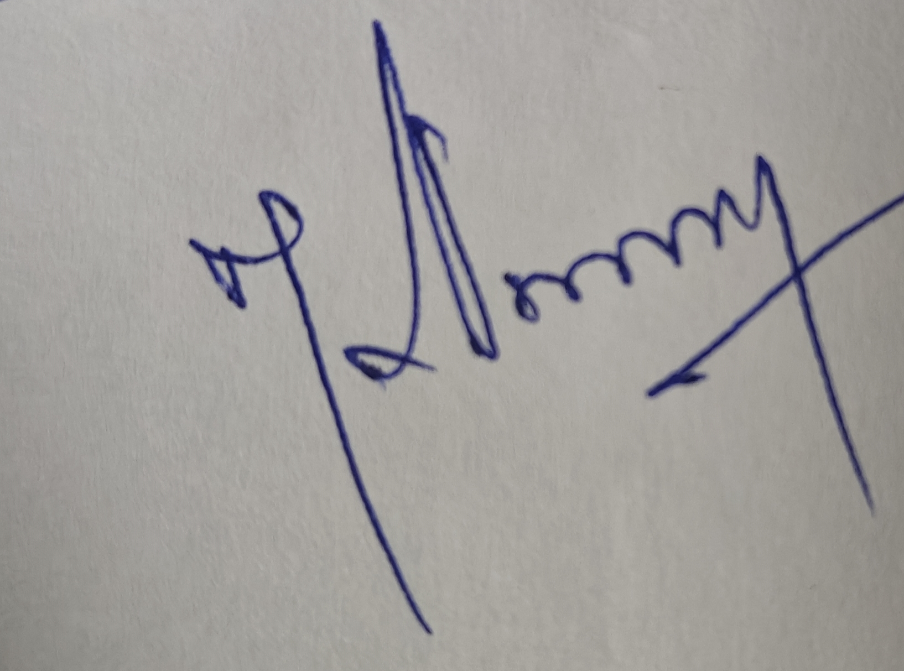

Date : 25.04.2025

*All future communication will be the principal author/project leader through email at this email ID
**If you are competing under SME stream, please certify your status as an SME, else you may leave it blank

