  IMTMA – ACE MICROMATIC  Productivity Championship Awards - 2025 |  |  |  | ENTRY FORM
 |  |  |  | Organization : |  |  | Tata Electronics Pvt Ltd Hosur Tamil Nadu
 |  |  |  | Principal author: |  |  | Ashokkumar Manogaran
 |  |  |  | Designation: |  |  | Senior Manager
 |  |  |  | Phone/ Mobile : |  |  | +91 919711862590
 |  |  |  | Email *: |  |  | ashok.manogaran@tataelectronics.co.in
ABSTRACT OF CASE STUDY
(Before filling the form please read the guidelines and rules)
1. | Industry Sector:  (Choose from the dropdown) | Choose an item.
 |  | Others(Specify) : | Electronics Manufacturing
2. | Size of the industry | MICRO & SMALL ENTERPRISE  (Unit level turnover <100 Crores.  Excludes SBUs of large corporates) |  |  | LARGE AND MEDIUM COMPANIES  (Unit level / SBU level turnover > Rs.100 Crores) |  |  | Turnover  (in Rs. Cr)  ___5563___________
3. | Title : “Intelligent CNC Manufacturing”
4 | Is the Project under continuous operation YES NO ☐
5.
  Scope of the Project: | Localized Point Improvement | ☐ | Line Improvement | ☐ | Companywide Improvement
5. | Date:(must be implemented after January 2021) | Start Date : 15-June-2024 |  |  |  | Completion Date : 15-03-2025
6
  Team Composition / Structure | Department resources | ☐ | CFT – Cross Functional Team (Company resources)
7. | Streams
7.
  Manufacturing System Redesign |  | Optimizing Metal Working Process |  | Better  Asset Utilization |  | Productivity Through Quality Improvement |  | Productivity Improvements in Small & Medium Enterprises (SME) |  | Others if any  (Specify)
  Cellular manufacturing, |  | Metal removal process | ☐ | Maximize overall equipment efficiency |  | Quality cost |  | To recognize SMEs which have taken up productivity improvement projects | ☐
  Factory within factory | ☐ | Metal forming process | ☐ | Space optimization | ☐ | Appraisal | ☐ | and to join the productivity movement, an exclusive stream has been slotted.
  Reducing throughput time | ☐ | Forging | ☐ | Inventory management | ☐ | Internal  failure | ☐
  Minimize setup/load/unload times | ☐ | Die casting | ☐ | Smart applications of CAD / CAM / Software tools | ☐ | External  failure | ☐ | SMEs can compete under SME stream or any of the other streams | ☐
  Tool management | ☐ | Heat treatment | ☐ | Leveraging IT | ☐ | Real time/in-process metrology | ☐
  Work holding | ☐ | Plating | ☐ | Product Redesign | ☐ | POKA- YOKE | ☐
   |  | Painting | ☐ | Process redesign | ☐ | Zero defect
   |  | Surface coating | ☐
   |  | Assembly | ☐
   |  | Finishing operations | ☐

8. | Reason for problem selection? |  |  | Responsive |  |  |  |  |  |  |  | Proactive ☐
8. | Brief description:  Our manufacturing facility is primarily facing significant issues related to elevated scrap and rejection rates, as well as time-consuming manual processes for analytical corrections in CNC machines.  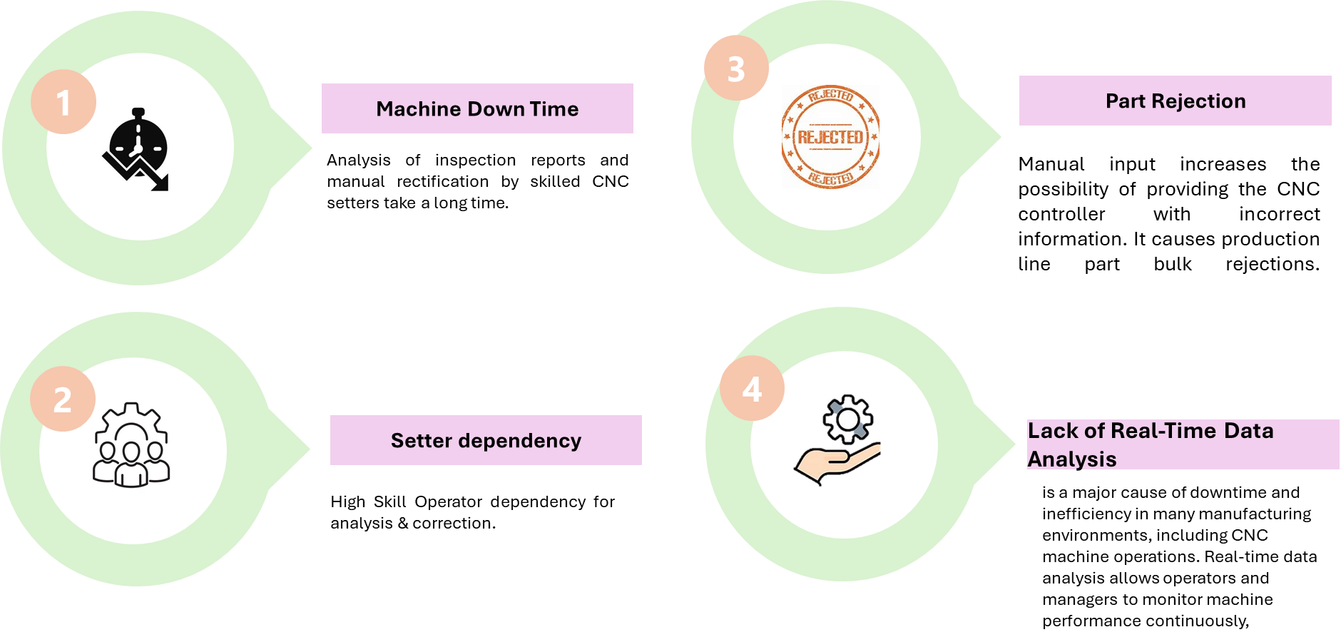
9. | Uniqueness of the project if any? | Approach | New concept |  |  |  |  |  | Breakthroughs |  |  |  |  |  |  |  |  | Patents |  | ☐
9. | Uniqueness of the project if any? | Results | Improvement % to base line
9. | Uniqueness of the project if any? | Results | 20 – 30% |  |  |  | 30-40% |  |  |  | ☐ |  | 40-50% |  |  |  | ☐ |  | >50%
9. | Uniqueness of the project if any? | Results | Status
9. | Uniqueness of the project if any? | Results | First time in the company |  |  |  |  | ☐ | First time in industry |  |  |  |  |  |  |  |  | Trend setter |  | ☐
10. | Tools used, (7 QC Tools , New 7 QC Tools, 6 Sigma , DOE , Theory of Constraints, Shainin Techniques, Project Management tools, Lean approach, Manufacturing system redesign, Digital manufacturing, TQM approach, TRIZ)  (Based on the tools used in the project, multiple options can be selected from the given dropdowns) |  |  |  | Digital manufacturing  7 QC Tools  6 Sigma  Project Management tools  Others(Specify): |  |  |  |  |  |  |  |  | Digital manufacturing  Choose an item.  Choose an item.  Choose an item.

11. | A brief insight into the Project (Not exceeding 500 words)
 | 11.1 | Reason for choosing the project:  At TEPL, the production area is equipped with a vast array of over 6,000 CNC machines, where proficient operators are essential for executing manual interventions and making precise dimensional modifications throughout various machining phases. The process of manual corrections often requires operators to stop the machine, assess the error, and make necessary adjustments, which can be quite time-consuming and lead to increased downtime and elevated labor expenses. Furthermore, the effectiveness of manual corrections is largely dependent on the operator's expertise and decision-making; any errors made during this process can result in additional complications, including improper machining or potential damage to either the workpiece or the machine itself.  To tackle the issue of 30-minute machine downtimes, it is crucial to pinpoint the underlying causes and establish a preventive maintenance schedule, while also training operators to efficiently manage minor problems. In response to the demand for a highly skilled (L4) CNC setter, we should either create internal training programs or recruit experienced professionals from the industry. Additionally, to improve our quality control measures, we need to identify and eliminate the root causes of part rejections during in-process quality control (IPQC) and establish a feedback loop for ongoing enhancement.  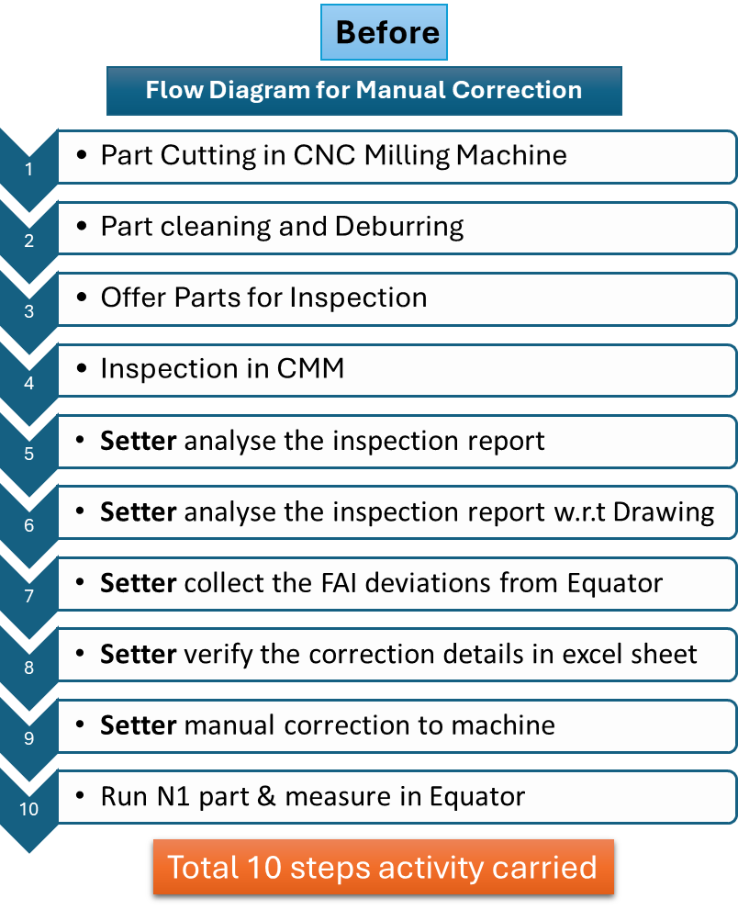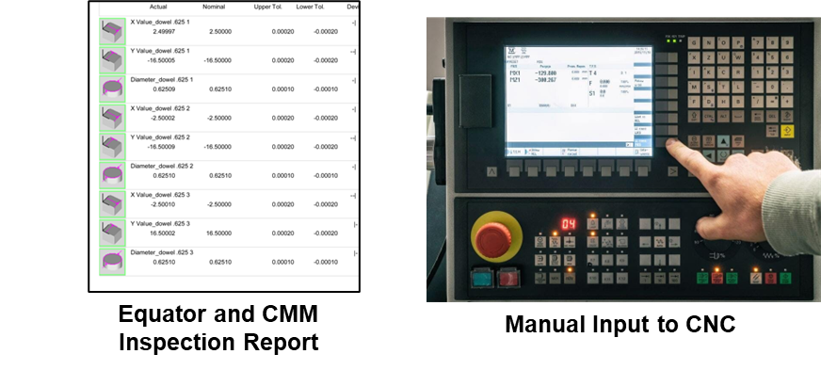
 | 11.2 | Objectives/ Target set for the project: (Outcome to be quantified)  Reduce scrap and rejection rates:  - Target: by improving the accuracy of machine operations, ensuring that parts are produced within the required tolerance.  Increase Production Efficiency:  - Target: Increase the machine’s production rate by 10% after innovative process integration  Reduce Machine Downtime:  - Target: Decrease machine downtime due to Intelligent compensation (Auto corrections) by 7%.  Improve Accuracy while auto Adjustments:  - Target: Achieve a 99% reduction in errors caused by manual adjustments.  Eliminate Skill Labour Dependency:  - Target: Reduce dependency on skilled labour by automating manual processes and enhancing process reliability.  Reduce Manual Interventions  - Target: Eliminate the manual intervention in CNC operations for offset correction.
 | 11.3 | Implementation details in brief (Not exceeding 200 words)  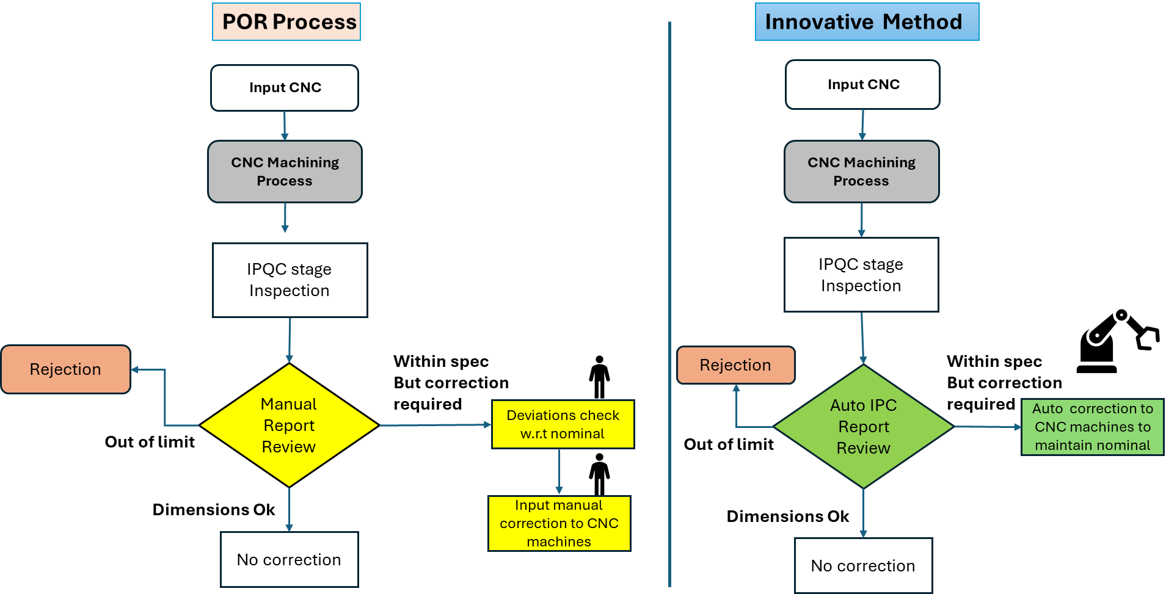  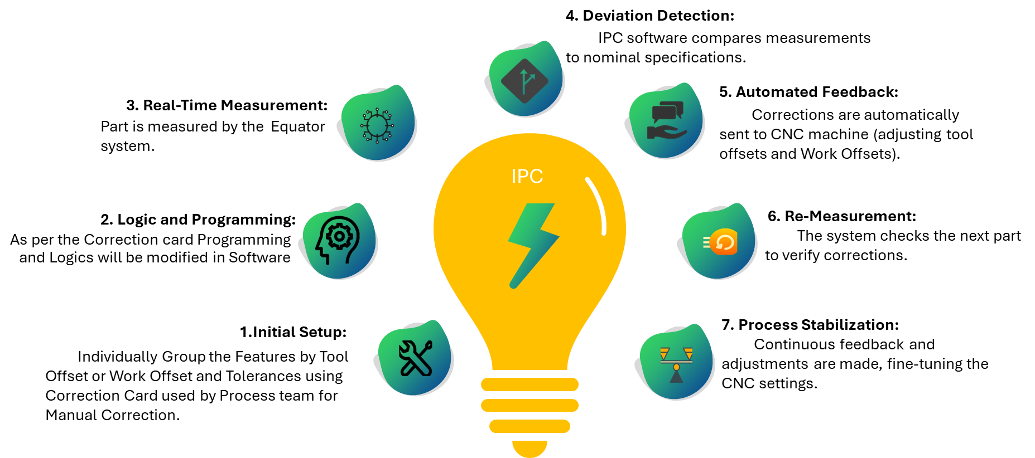  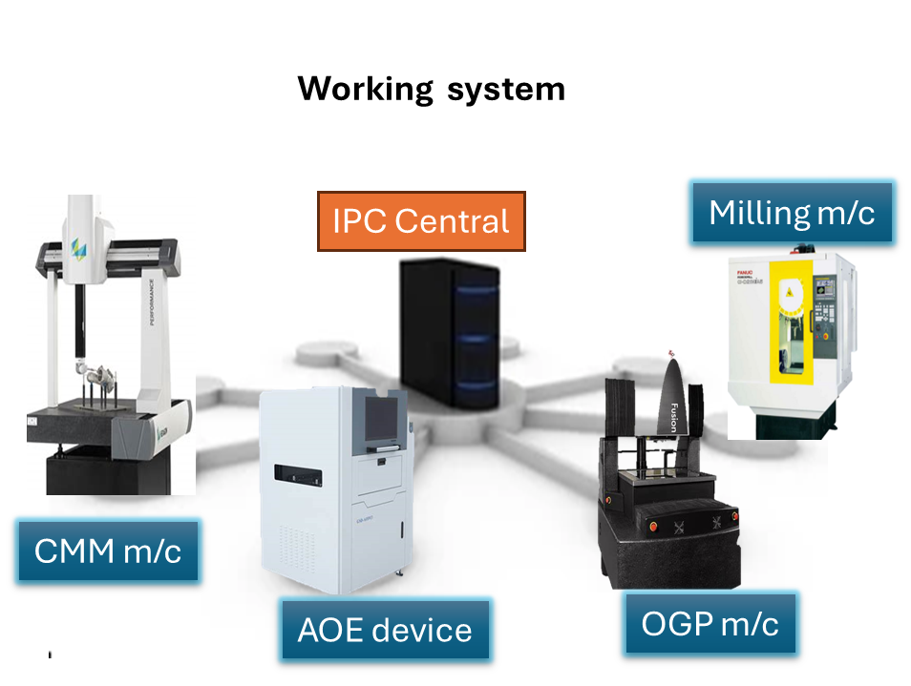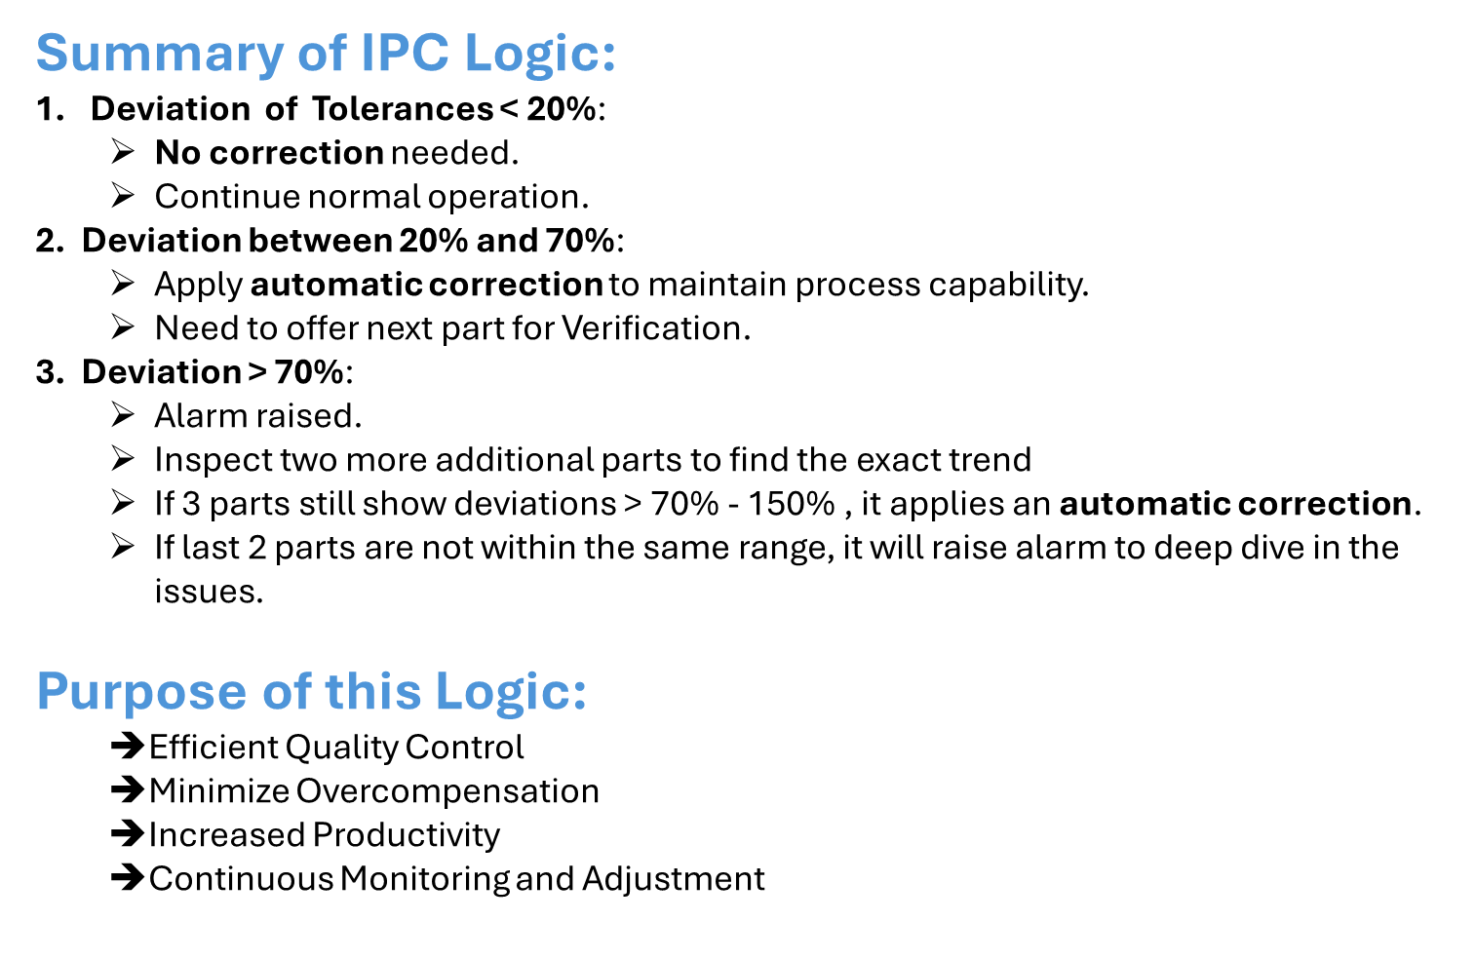
 | 11.4 | Overall schematic flow diagram for the project from start to completion  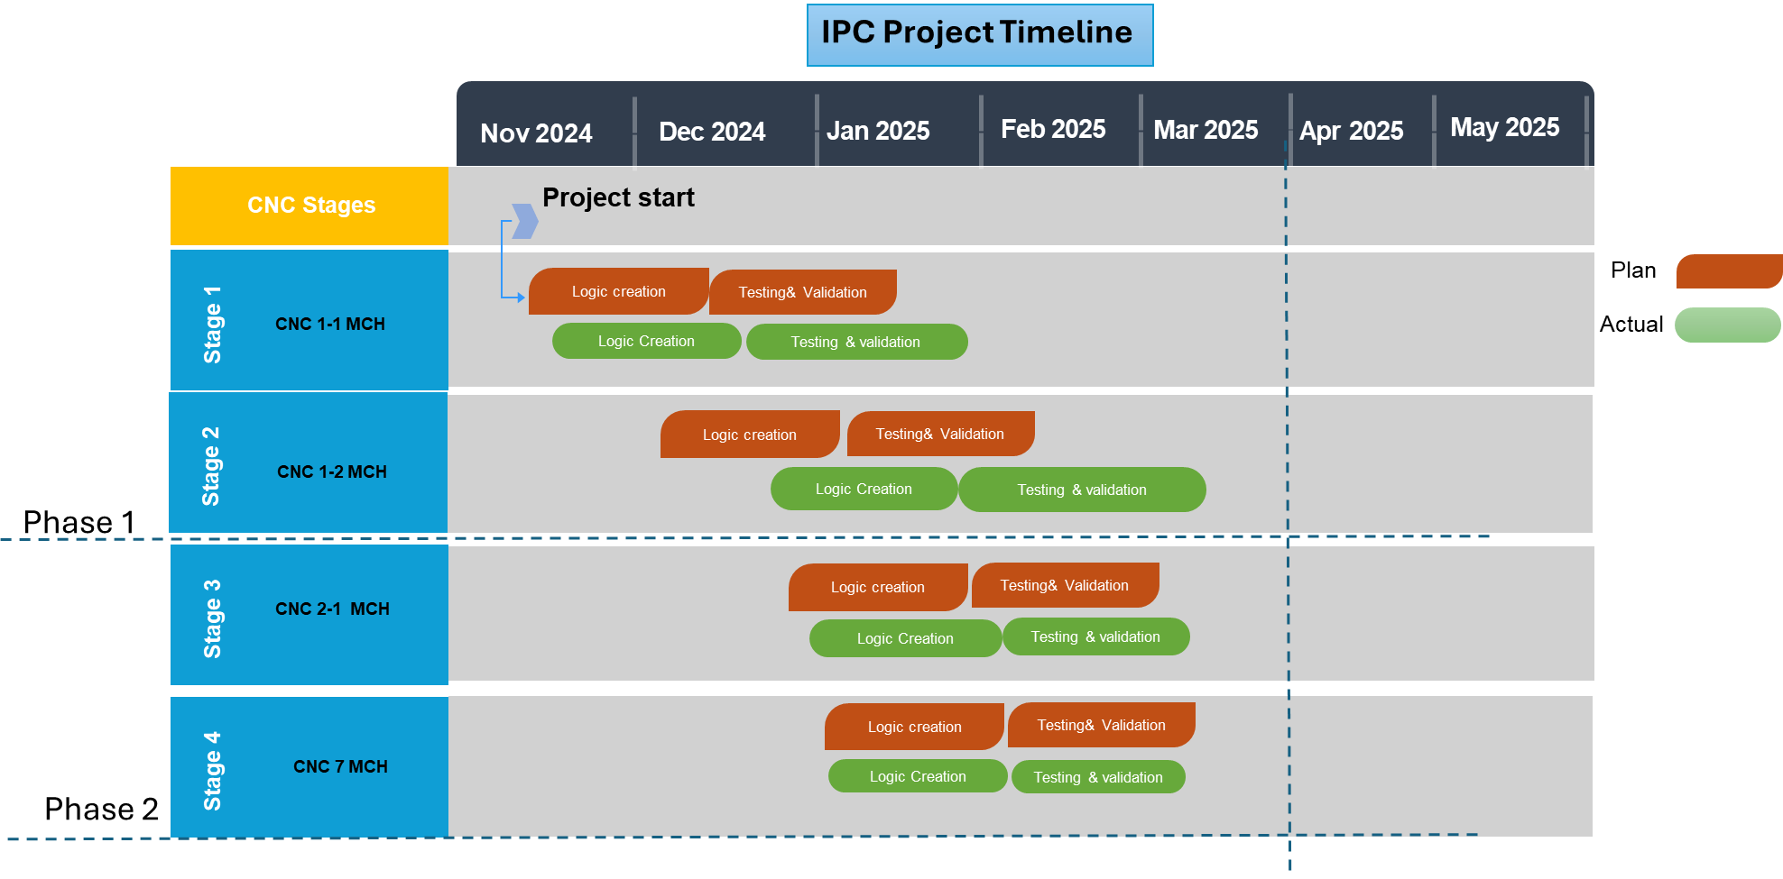
 | 11.5 | Operational Benefits – Covering Productivity, Quality, Cost, Delivery, EHS (To be quantified)  - Productivity: Productivity increased after machine down time elimination M/C Idle Time saving  968760 Hours/Year for 1794 Machines.  - Quality: FPY increased from 92.5% to 99.5%  - Cost: ₹19,09,44,000 Revenue will be generated by implementing this project.  - Delivery: Setter correction time reduced 15 mins/mc/report  - Machine Availability: (A*P) increased 7%  - EHS: Carbon footprint reduction 190 tonnes’/year  - Morel: Automatic system increases confidence level for Operation team.
 | 11.6 | Business Benefits: Cost benefit ratios, Savings one time & recurring, Investment vs Return, Market share  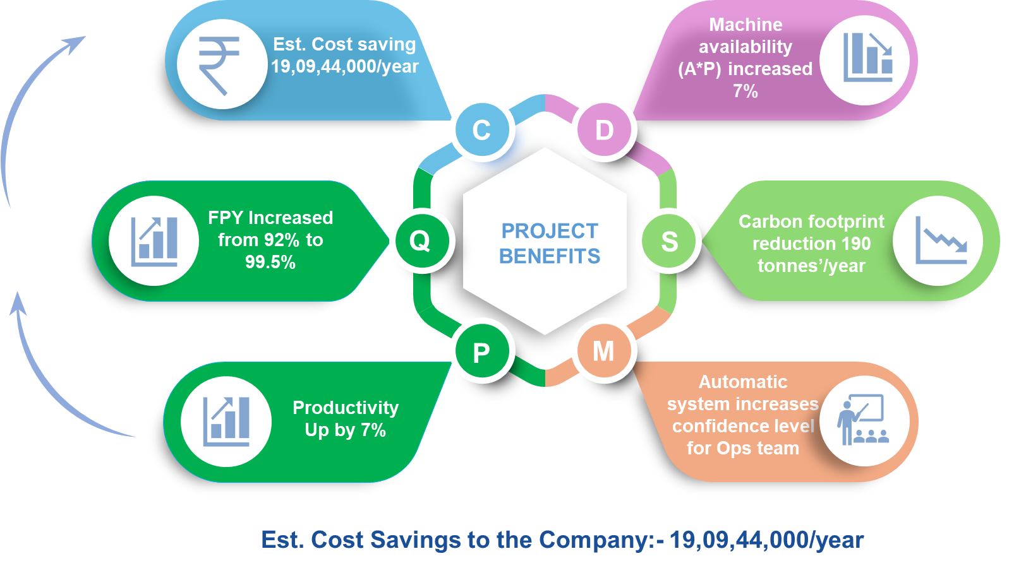
12. | ** We Certify that we are classified as a Micro / Small with the Udyam Registration Certificate number: __________with the Major Activity as___________ [Please ignore if it is not applicable to your company]
Company Authorization
We certify that the project described here is factually correct and is in continuous operation. We confirm that we have read the rules and guidelines governing this competition and agree to abide by the same.
Name :Ashokkumar Manogaran Designation :Senior Manager Signature :

Date :

*All future communication will be the principal author/project leader through email at this email ID
**If you are competing under SME stream, please certify your status as an SME, else you may leave it blank

Rules & Guidelines governing the competition
Competition open to companies engaged in the manufacture of Engineering products / Components.

Contestants are advised to read the following guidelines carefully before filling in the format

- The objective of National Productivity Summit is to showcase best productivity practices in Indian manufacturing space, by sharing knowledge and experience.  - Participation in this competition is FREE.  - Download and submit the entry form by logging on to www.productivity.imtma.in on or before 5 April 2025. Please ensure that the file size being uploaded does not exceed 15 MB. Subsequently the hard copy of the entry duly signed and certiﬁed by the senior management should be sent to IMTMA's Bangalore oﬃce at the below address.  - There will be separate awards for Automotive and Non-Automotive sectors and SME Sector  - To participate, please fill in the attached entry form and e-mail it to madan@imtma.in OR abhishek@imtma.in . Please send the hard copy to IMTMA Bangalore office mentioned below.  - Abstracts should be written in the space provided.  - Provide the principal author's (Project leader) name and contact details. All future communication will be through email.  - Name(s) of additional authors may be included in the final case study.  - Give details of when the project was implemented in your organization, and it is/was in continuous operation for 12 months.  - Companies must submit Case study(s)that will showcase and highlight breakthrough achievements that have brought significant competitive advantage to the company. The case study(s) must clearly bring out the value creation and results achieved.  - While companies can send a maximum of 2 entries per plant/ manufacturing location, please note that only ONE best entry shall be considered for evaluation.  - Project must have been implemented and put into regular operation for a minimum period of one year. The project start date must be after January 2021. Entries that were submitted for the previous IMTMA Productivity championship competition(s) must not be resubmitted. Such entries will be summarily disqualified.  Note:  - Minor improvements, Kaizens, will not be considered. Participants are expected to submit case studies that have brought in significant improvements to their business.  - Projects having application of standard products for productivity improvement / Service plugins that are commercially available will not be considered. | - For the next round, the contestants of the selected case studies from this evaluation will prepare and submit a detailed presentation. From these presentations, the jury will shortlist the finalists who will then present their case studies live on stage at the National Productivity Summit 2025 scheduled during November 2025, Ahmedabad. A member of the Senior Management from the organization who is directly responsible for the project implementation will be needed to make this presentation. The presentation must be made in English language only.  - Entries will be judged by an independent jury comprising of eminent professionals, whose decision will be final. While significant weightage will be given to the conceptualization, link to business need, associated impact, value creation to stakeholders and business sustainability parameters, the other criteria for evaluation will also include analysis, determination of requirements, generation and evaluation of alternative solutions, innovativeness and the thoroughness of planning and implementation. Neither IMTMA nor ACE MICROMATIC will have any role in judging of entries. The jury reserves the right to accept or reject an entry without assigning any reasons thereof. Therefore IMTMA is not obliged to provide reasons for rejection.  - Projects may be validated onsite (physically or virtually) by the evaluation team as part of the process, if required.  - Winners will be awarded cash prizes, a trophy and a certificate. Multiple or partial awards may also be given. Cash prizes will be awarded to Individuals / Team Members.  - Presentations can contain concepts and broad contours of the project without disclosing confidential information. Applicants are assured of the confidentiality and their IP rights.  For any queries please contact:  INDIAN MACHINE TOOL MANUFACTURERS' ASSOCIATION (IMTMA)  @ Bangalore International Exhibition Centre (BIEC)  10th Mile, Tumkur Road, Madavara Post, Bangalore – 562 123  Madan (Email: madan@imtma.in  Mob: 7899437625, Tel: 080 66246711)  Or  Abhishek (Email: abhishek@imtma.in  Mob: 9844294387, Tel: 080 66246829)

