  IMTMA – ACE MICROMATIC  Productivity Championship Awards - 2025 |  |  |  | ENTRY FORM
 |  |  |  | Organization : |  |  | Mangal Industries Limited
 |  |  |  | Principal author: |  |  | Suresh P
 |  |  |  | Designation: |  |  | Sr.Manager
 |  |  |  | Phone/ Mobile : |  |  | 9701125142
 |  |  |  | Email *: |  |  | psh@amararaja.com
ABSTRACT OF CASE STUDY
(Before filling the form please read the guidelines and rules)
1. | Industry Sector:  (Choose from the dropdown) | General Engineering
 |  | Others(Specify) : | Sheet Metal Parts Manufacturing
2. | Size of the industry | MICRO & SMALL ENTERPRISE  (Unit level turnover <100 Crores.  Excludes SBUs of large corporates) |  |  | LARGE AND MEDIUM COMPANIES  (Unit level / SBU level turnover > Rs.100 Crores) |  |  | Turnover  (in Rs. Cr)  ____560__________
3. | Title : Production Capacity Enhancement in Roll Forming Process through Process Optimization
4 | Is the Project under continuous operation YES NO ☐
5.
  Scope of the Project: | Localized Point Improvement | ☐ | Line Improvement | ☐ | Companywide Improvement
5. | Date:(must be implemented after January 2021) | Start Date : June 2024 |  |  |  | Completion Date : January 2025
6
  Team Composition / Structure | Department resources | ☐ | CFT – Cross Functional Team (Company resources)
7. | Streams
7.
  Manufacturing System Redesign |  | Optimizing Metal Working Process |  | Better  Asset Utilization |  | Productivity Through Quality Improvement |  | Productivity Improvements in Small & Medium Enterprises (SME) |  | Others if any  (Specify)
  Cellular manufacturing, | ☐ | Metal removal process | ☐ | Maximize overall equipment efficiency |  | Quality cost |  | To recognize SMEs which have taken up productivity improvement projects
  Factory within factory | ☐ | Metal forming process |  | Space optimization | ☐ | Appraisal | ☐ | and to join the productivity movement, an exclusive stream has been slotted.
  Reducing throughput time | ☐ | Forging | ☐ | Inventory management | ☐ | Internal  failure | ☐
  Minimize setup/load/unload times |  | Die casting | ☐ | Smart application of CAD / CAM / Software tools | ☐ | External  failure | ☐ | SMEs can compete under SME stream or any of the other streams | ☐
  Tool management | ☐ | Heat treatment | ☐ | Leveraging IT | ☐ | Real time/in-process metrology | ☐
  Work holding | ☐ | Plating | ☐ | Product Redesign | ☐ | POKA- YOKE
   |  | Painting | ☐ | Process redesign | ☐ | Zero defect
   |  | Surface coating | ☐
   |  | Assembly | ☐
   |  | Finishing operations | ☐

8. | Reason for problem selection? |  |  | Responsive |  |  |  |  |  |  |  | Proactive ☐
8. | Brief description:  This project addressed critical production capacity shortfalls in our roll forming operations, where actual production consistently fell below theoretical capacity by 10-30%. Analysis of six months of production data (June-October 2024) revealed significant machine downtime averaging 546.5 hours monthly, with lip damage problems (145 hrs) and side roller adjustment issues (123 hrs) as major contributors.
9. | Uniqueness of the project if any? | Approach | New concept |  |  |  |  | ☐ | Breakthroughs |  |  |  |  |  |  |  |  | Patents |  | ☐
9. | Uniqueness of the project if any? | Results | Improvement % to base line
9. | Uniqueness of the project if any? | Results | 20 – 30% |  |  | ☐ | 30-40% |  |  |  |  |  | 40-50% |  |  |  | ☐ |  | >50% | ☐
9. | Uniqueness of the project if any? | Results | Status
9. | Uniqueness of the project if any? | Results | First time in the company |  |  |  |  |  | First time in industry |  |  |  |  |  |  | ☐ |  | Trend setter |  | ☐
10. | Tools used, (7 QC Tools , New 7 QC Tools, 6 Sigma , DOE , Theory of Constraints, Shainin Techniques, Project Management tools, Lean approach, Manufacturing system redesign, Digital manufacturing, TQM approach, TRIZ)  (Based on the tools used in the project, multiple options can be selected from the given dropdowns) |  |  |  | 7 QC Tools  Lean approach  Choose an item.  Choose an item.  Others(Specify): |  |  |  |  |  |  |  |  | Choose an item.  Choose an item.  Choose an item.  Choose an item.

11. | A brief insight into the Project (Not exceeding 500 words)
 | 11.1 | Reason for choosing the project:  This project addressed critical production capacity shortfalls in our roll forming operations, where actual production consistently fell below theoretical capacity by 10-30%. Analysis of six months of production data (June-October 2024) revealed significant machine downtime averaging 546.5 hours monthly, with lip damage problems (145 hrs) and side roller adjustment issues (123 hrs) as major contributors.
 | 11.2 | Objectives/ Target set for the project: (Outcome to be quantified)  Analysis of production data over five months revealed persistent gaps between theoretical capacity (15.12 lakhs components/month) and actual production (ranging from 10.51 to 13.93 lakhs/month). Despite having six machines capable of producing 50,400 components daily (8,400 per machine at 8 components/minute), actual production consistently underperformed by 10-30%.  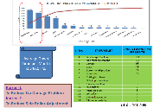  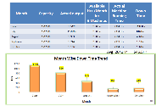  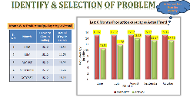
 | 11.3 | Implementation details in brief (Not exceeding 200 words)  - Kaizen 1: Lip Damage Reduction  - Root Cause: Roller mounting plate was mounted as simply supported structure  - Innovation: Engineering design modification with connecting plate and welding to prevent roller adjustment issues  - Complexity: Required precision engineering while maintaining production capability  - Kaizen 2: Side Roller Adjustment Reduction  - Root Cause: Roller holding circlips getting broken  - Innovation: Replacement of circlips with bolt, nut and washer assembly  - Complexity: Needed to design solution that could withstand vibration and continuous operation
 | 11.4 | 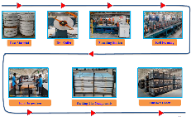  Overall schematic flow diagram for the project from start to completion:  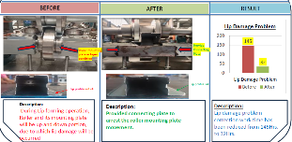  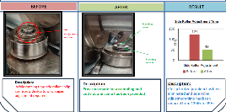
 | 11.5 | Operational Benefits – Covering Productivity, Quality, Cost, Delivery, EHS (To be quantified)  - Productivity Increased by 26%  - Scrap reduced by 3%  - Downtime reduced by 52%  - Visual Rejection PPM Reduced by 75%
 | 11.6 | Business Benefits: Cost benefit ratios, Savings one time & recurring, Investment vs Return, Market share  - 1.5 Crs Savings from scrap reduction on direction reduction of RM
12. | ** We Certify that we are classified as a Micro / Small with the Udyam Registration Certificate number: __________with the Major Activity as___________ [Please ignore if it is not applicable to your company]
Company Authorization
We certify that the project described here is factually correct and is in continuous operation. We confirm that we have read the rules and guidelines governing this competition and agree to abide by the same.
Name : Suresh P Designation : Sr. Manager Signature : Suresh P

Date : 25/4/2025

*All future communication will be the principal author/project leader through email at this email ID
**If you are competing under SME stream, please certify your status as an SME, else you may leave it blank

Rules & Guidelines governing the competition
Competition open to companies engaged in the manufacture of Engineering products / Components.

Contestants are advised to read the following guidelines carefully before filling in the format

- The objective of National Productivity Summit is to showcase best productivity practices in Indian manufacturing space, by sharing knowledge and experience.  - Participation in this competition is FREE.  - Download and submit the entry form by logging on to www.productivity.imtma.in on or before 5 April 2025. Please ensure that the file size being uploaded does not exceed 15 MB. Subsequently the hard copy of the entry duly signed and certiﬁed by the senior management should be sent to IMTMA's Bangalore oﬃce at the below address.  - There will be separate awards for Automotive and Non-Automotive sectors and SME Sector  - To participate, please fill in the attached entry form and e-mail it to madan@imtma.in OR abhishek@imtma.in . Please send the hard copy to IMTMA Bangalore office mentioned below.  - Abstracts should be written in the space provided.  - Provide the principal author's (Project leader) name and contact details. All future communication will be through email.  - Name(s) of additional authors may be included in the final case study.  - Give details of when the project was implemented in your organization, and it is/was in continuous operation for 12 months.  - Companies must submit Case study(s)that will showcase and highlight breakthrough achievements that have brought significant competitive advantage to the company. The case study(s) must clearly bring out the value creation and results achieved.  - While companies can send a maximum of 2 entries per plant/ manufacturing location, please note that only ONE best entry shall be considered for evaluation.  - Project must have been implemented and put into regular operation for a minimum period of one year. The project start date must be after January 2021. Entries that were submitted for the previous IMTMA Productivity championship competition(s) must not be resubmitted. Such entries will be summarily disqualified.  Note:  - Minor improvements, Kaizens, will not be considered. Participants are expected to submit case studies that have brought in significant improvements to their business.  - Projects having application of standard products for productivity improvement / Service plugins that are commercially available will not be considered. | - For the next round, the contestants of the selected case studies from this evaluation will prepare and submit a detailed presentation. From these presentations, the jury will shortlist the finalists who will then present their case studies live on stage at the National Productivity Summit 2025 scheduled during November 2025, Ahmedabad. A member of the Senior Management from the organization who is directly responsible for the project implementation will be needed to make this presentation. The presentation must be made in English language only.  - Entries will be judged by an independent jury comprising of eminent professionals, whose decision will be final. While significant weightage will be given to the conceptualization, link to business need, associated impact, value creation to stakeholders and business sustainability parameters, the other criteria for evaluation will also include analysis, determination of requirements, generation and evaluation of alternative solutions, innovativeness and the thoroughness of planning and implementation. Neither IMTMA nor ACE MICROMATIC will have any role in judging of entries. The jury reserves the right to accept or reject an entry without assigning any reasons thereof. Therefore IMTMA is not obliged to provide reasons for rejection.  - Projects may be validated onsite (physically or virtually) by the evaluation team as part of the process, if required.  - Winners will be awarded cash prizes, a trophy and a certificate. Multiple or partial awards may also be given. Cash prizes will be awarded to Individuals / Team Members.  - Presentations can contain concepts and broad contours of the project without disclosing confidential information. Applicants are assured of the confidentiality and their IP rights.  For any queries please contact:  INDIAN MACHINE TOOL MANUFACTURERS' ASSOCIATION (IMTMA)  @ Bangalore International Exhibition Centre (BIEC)  10th Mile, Tumkur Road, Madavara Post, Bangalore – 562 123  Madan (Email: madan@imtma.in  Mob: 7899437625, Tel: 080 66246711)  Or  Abhishek (Email: abhishek@imtma.in  Mob: 9844294387, Tel: 080 66246829)

Productivity Championship Project Report

Project Title: Production Capacity Enhancement in Roll Forming Process through Process Optimization
About Mangal Industries Ltd.:
Mangal Industries Limited is part of the USD 1.5 Billion Amara Raja Group conglomerate operating 16 businesses across 7 companies with a workforce of 16,000+ people. Mangal Industries specializes in Battery Components, Auto Components, Metal Fabrications, Storage Solutions, and Custom Fabrications, serving both internal customers within the Amara Raja Group and external customers in various industries.
The company's vision is to continually redefine business to deliver high social impact by anticipating future trends, building preferred brands, and leveraging talent & technology. Mangal Industries embodies core values of entrepreneurship (orange), responsibility (green), innovation (burgundy), experiences (blue), and excellence (magenta).
Brief Description of the Project:
In response to growing market demand and to uphold our commitment to customer centricity, Mangal Industries embarked on a project to optimize the roll forming process in our metal fabrication division. The challenge was to meet production capacity targets that were consistently not being achieved, particularly in the manufacturing of solar panel back rails and other metal components. This project focused on identifying and addressing bottleneck areas within the roll forming production process to implement targeted improvements that would enhance productivity and reduce downtime.
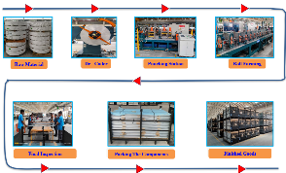
Trigger for the Project:
Analysis of production data over a six-month period (June to October 2024) revealed that actual production consistently fell below capacity:
Month | Capacity (Qty. in Lakhs) | Actual (Qty. in Lakhs) | Gap
June | 15.12 | 10.51 | 4.61
July | 15.12 | 11.78 | 3.34
August | 15.12 | 13.93 | 1.19
September | 15.12 | 13.24 | 1.88
October | 15.12 | 13.16 | 1.96

Our theoretical capacity calculations showed:
- Number of Machines: 6
- Machine RPM per component: 18 M/Min
- Components produced per minute: 8
- Available time per day: 1050 minutes
- Production capacity per machine per day: 8,400 components
- Total production capacity for 6 machines per day: 50,400 components
- Total monthly capacity: 15.12 Lakhs
Investigation of machine downtime revealed significant issues:
- Average monthly downtime: 546.5 hours
- Key downtime factors: Lip damage problems (145 hrs/month) and side roller adjustment (123 hrs/month)
This persistent gap between capacity and actual production triggered the need for a structured improvement project to identify and address root causes.
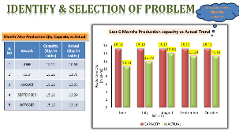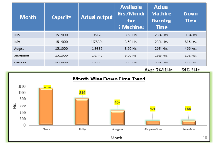
Solution Generation, Innovation and Complexity:
After thorough analysis of the project scope and current challenges, we embraced a systematic improvement approach:
- Identification & Selection of Kaizen Theme: Based on production data analysis, we selected "Production Capacity Enhancement" as our primary focus.
- Problem Analysis Framework: We followed a structured six-step approach:
  - Identification & Selection of Improvement Areas
  - Definition of Project Themes
  - Analysis of Root Causes
  - Development of Solutions
  - Trial Implementation & Kaizen Development
  - Regular Implementation & Standardization
- Root Cause Analysis: We utilized multiple analytical tools:
  - Pareto Analysis: Identified that Lip damage problems (145 hrs) and Side roller adjustment (123 hrs) constituted approximately 49% of total downtime
  - Ishikawa (Fishbone) Diagram: Analyzed causes across Man, Material, Machine, and Method categories
  - Why-Why Analysis: Determined fundamental root causes for major issues

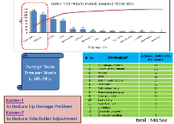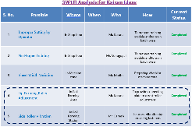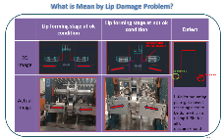

- Solution Development Process:
  - We evaluated potential solutions based on cost, feasibility, and implementation time
  - Prioritized solutions for maximum impact with minimal investment
  - Created detailed implementation plans with clear ownership and timelines
- Innovative Solutions:
  - Kaizen 1: Lip Damage Reduction
    - Root Cause: Roller mounting plate was mounted as simply supported structure
    - Innovation: Engineering design modification with connecting plate and welding to prevent roller adjustment issues
    - Complexity: Required precision engineering while maintaining production capability
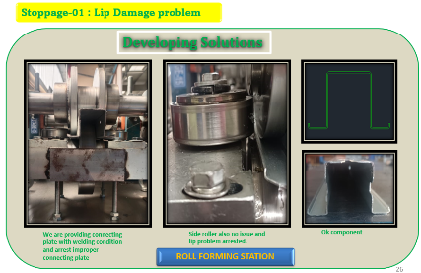
  - Kaizen 2: Side Roller Adjustment Reduction
    - Root Cause: Roller holding circlips getting broken
    - Innovation: Replacement of circlips with bolt, nut and washer assembly
    - Complexity: Needed to design solution that could withstand vibration and continuous operation
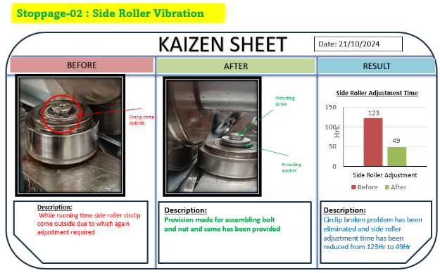
Implementation:
Our implementation approach was systematic and thorough:
- Training and Skill Development:
  - Created comprehensive training modules for operators
  - Conducted batch-wise training to ensure all operators understood proper machine settings
  - Implemented standardized checklists for machine zone preparation
- Engineering Modifications:
  - For Lip Damage Issue:
    - Designed and fabricated connecting plates for roller mounting structures
    - Implemented welded connections to replace simply supported structures
    - Created visual standards for proper and improper lip profiles
  - For Side Roller Adjustment Issue:
    - Replaced failure-prone circlips with engineered bolt-nut-washer assemblies
    - Modified roller mounting system to enhance stability during operation
    - Established standard procedures for roller assembly
- Process Standardization:
  - Prepared detailed checklist for machine setup and material inspection
  - Created visual management tools for proper/improper conditions
  - Established standard work procedures for critical operations
- Implementation Monitoring:
  - Daily tracking of downtime causes
  - Weekly review of implementation effectiveness
  - Monthly assessment of overall performance metrics
Throughout the implementation phase, we maintained a proactive approach with regular monitoring and adjustment of strategies as needed. This systematic execution of action plans with clear ownership and timelines ensured successful navigation of challenges to achieve project objectives.
Results / Impact:
Mandatory Parameters:
Parameter | Before | After | Unit of Measurement | Improvement
1. Productivity details
Monthly Production Output | 10.51-13.93 | 14.25-14.90 | Lakhs | 26% increase
Machine Utilization | 2304-2999 | 3080 | Hours/month | 24% increase
2. Reduction of rejects and rework | 556.5 | 268.5 | Hours/month | 52% reduction
3. Quality (Customer complaint) | 8 | 2 | Number | 75% reduction
4. Direct Cost saving (Recurring) | - | 18.6 | Lakhs/annum | New saving
5. Manpower cost | No change | No change | NA | NA
6. Delivery | 87% | 98% | % On-time delivery | 11% improvement
7. Safety | 12 | 3 | Unsafe conditions | 75% reduction
8. Space creation | No change | No change | NA | NA
9. Travelling distance reduction | 12.4 | 8.3 | Km per shift | 33% reduction
Specific Results from Kaizen Implementation:
Kaizen | Before (Hrs) | After (Hrs) | Saving (Hrs)
To Reduce Lip Damage Problem | 145 | 32 | 113
To Reduce Side Roller Adjustment Problem | 123 | 49 | 74
Total Savings |  |  | 187 hrs/month
The combined effect of these improvements resulted in:
- Total downtime reduction from 546.5 hours to 268.5 hours per month (52% reduction)
- Actual production increase to 14.90 lakhs by January 2025 (compared to capacity of 15.12 lakhs)
- Production capacity utilization improved from 69.5% to 98.5%
Resource Impact:
Parameters | Before | After | Unit of Measurement | Improvement
1. CO2 Reduction | 1825 | 1277 | Tons per annum | 30% reduction
2. H2O Footprint Reduction | 0.95 | 0.75 | KL per 1000 components | 21% reduction
3. Energy consumption | 63.5 | 58.2 | Units per 1000 components | 8% reduction
4. Compressed air reduction | 42.3 | 38.6 | CFM/1000 components | 9% reduction
5. Solid Waste Reduction | 12.8 | 9.2 | Kg/1000 components | 28% reduction

Business Sustainability and Future Focus:
After implementing productivity improvements, the capacity of our roll forming operations has significantly increased, with production volumes approaching theoretical capacity. This achievement not only addresses the current business requirements but also underscores our commitment to business sustainability and future growth.
The key aspects of sustainable business impact include:
- Capacity Utilization: Improved from 69.5% to 98.5%, enabling us to meet growing customer demand without additional capital investment.
- Resource Efficiency: Significant reductions in energy, water, and material usage have created both environmental and economic benefits.
- Quality Improvement: 75% reduction in customer complaints enhances our reputation and market position.
- Knowledge Development: The systematic problem-solving approach has built organizational capabilities that can be applied to future challenges.
Future Focus:
The success of this project has created a foundation for continued improvement. Our next targeted projects include:
- Roll Forming Section:
  - Addressing camber and twist problems (next highest downtime causes)
  - Further optimization of roll forming processes
- Horizontal Deployment:
  - Extending the methodology to other production areas
  - Creating standardized approaches for similar issues across the organization
- Digital Enhancement:
  - Implementing real-time monitoring systems
  - Developing predictive maintenance capabilities
These initiatives will ensure continued progress in productivity improvement and maintain our competitive edge in the market.
Scope of Horizontal Deployment:
The methodologies and solutions developed in this project have high potential for horizontal deployment across other manufacturing areas:
- Similar Process Areas: The approach can be directly applied to other roll forming lines and similar metal forming processes within our organization.
- Systematic Problem-Solving: The structured approach to problem identification, root cause analysis, and solution development provides a template for addressing productivity challenges in any manufacturing process.
- Training Modules: The operator training programs developed can be adapted for different equipment and processes.
- Visual Management Standards: The visual standards created for "OK/Not OK" conditions can be extended to other quality parameters.
- Resource Optimization: The methodologies for reducing energy, water, and material consumption can be applied organization-wide.
The success of this project has already sparked interest from other departments, and we have scheduled knowledge-sharing sessions to facilitate broader adoption of these improvement approaches throughout the organization.

